SIMATS ENGINEERING
Department of Computer Science and Engineering

CSA15 Cloud Computing and Big Data Analytics
CO4 AT1 - Big Data Analytics Class Test Student Template

Course Code | CSA15 | Slot | B
Course Title | Cloud Computing and Big Data Analytics | Assessment | CO4 AT1
Assessment Title | Big Data Analytics Class Test | Bloom Level | BL4 - Analyze
Faculty | Dr C. Rajesh Babu | Employee ID | SSETSCS415
Submission Mode | Individual digital answer template through GitHub and Google Classroom | Total Marks | 30

Student Details

Student Name | K.Varshini | Register Number | 192472358
Class / Section | CSE-AI | Slot | B
Capstone Title | SkillHire: AI Resume Screening and Job-Fit Android App | Submission Date
GitHub Repository Link | https://github.com/varshinvarma101 | Google Classroom
 | 0/CSA1512.git
 |  | Status | completed

Assessment Overview
CO4 Focus
Analyze big data characteristics, processing needs, security challenges, business drivers and domain applications. This template includes explanation notes to guide the thinking process. The final answer must be written in the student's own words.
How to use this template:
- Read each question and the explanation notes before answering.
- Use your capstone product as an example wherever relevant.
- Write concise technical answers; avoid copying the explanation notes directly.
- Use diagrams or small tables wherever they improve clarity.
- Upload the completed DOCX/PDF and supporting evidence to GitHub; share the repository link through Google Classroom.

Assessment Rubric

Criteria | Marks | Evaluation Focus | Student Check
Concept Accuracy | 9 | Correct technical meaning, terminology and examples. | Have I used correct big data terms?
Coverage | 6 | All required parts of the question are answered. | Have I answered every part?

Examples | 4.5 | Relevant cloud/capstone/domain examples are included. | Have I used meaningful examples?
Analysis | 6 | Implications, security, scalability and decision value are explained. | Have I explained why it matters?
Clarity | 4.5 | Answer is organized, concise and readable. | Is my answer easy to evaluate?

Code of Conduct and Student Assurance
I K.Varshini(192472358)(Name / Register Number) certify that this submission is my original work and that I have adhered to the guidelines specified for this assessment.
I understand that any violation of academic integrity rules will result in disciplinary action. Signature of the student: K.Varshini

Question and Answer Sections
Answer all questions. Each question carries 3 marks. Use the explanation notes for direction, but write the final answer independently.

Question 1 (3 Marks)
Define Big Data and explain why traditional data processing approaches are often insufficient for big data environments.

Explanation Notes

1 | Start with a precise definition: Big Data refers to datasets whose size, speed, variety or complexity exceeds the capability of conventional tools.
2 | Mention why spreadsheets or single-server databases struggle: storage limits, slow queries, concurrency issues, schema rigidity and limited scalability.
3 | Use one cloud/capstone-style example such as app logs, IoT feeds, transactions, images or clickstream events.
4 | End with why distributed storage and parallel processing become necessary.

Student Response
Context:
In SkillHire, processing thousands of unstructured PDF resumes and millions of job board postings concurrently causes single-server database locks. Distributed storage architectures (e.g., Cloud Object Stores) and parallel processing frameworks (e.g., Apache Spark) become essential to distribute compute across a cluster and parse documents simultaneously.
Definition of Big Data:
Big Data refers to massive, complex datasets whose volume, generation speed (velocity), structural diversity (variety), and uncertainty (veracity) surpass the ingestion, storage, querying, and processing capabilities of conventional relational database management systems (RDBMS).
Why Traditional Data Processing Approaches Fail:
- Storage and Monolithic Bottlenecks: Traditional RDBMS systems rely on vertical scaling (Scale-Up), requiring expensive hardware upgrades on single-node servers that eventually hit physical CPU, memory bus, and storage controller ceilings.
- Schema Rigidity: Relational databases enforce strict pre-defined tabular schemas (ACID properties), which degrade when attempting to ingest polymorphic, unstructured, or rapidly evolving formats such as PDF resumes, video streams, or semi-structured clickstream logs.
- Query Latency and Concurrency Limits: As records scale into millions or billions of rows, table joins, multi-index searches, and aggregate scans trigger severe I/O disk thrashing and query timeouts.

Question 2 (3 Marks)
Explain the 5Vs of Big Data with one practical example for any two Vs.

Explanation Notes

1 | List the 5Vs clearly: Volume, Velocity, Variety, Veracity and Value.
2 | For at least two Vs, connect the definition to a concrete scenario instead of writing only textbook meaning.
3 | Example: In a smart traffic system, velocity refers to continuous vehicle movement updates; value refers to congestion prediction.
4 | Show that each V affects system design, storage, processing or analytics decisions.

Student Response
The five Vs of Big Data are Volume, Velocity, Variety, Veracity and Value. Volume represents the large amount of resumes, job postings and candidate records handled by SkillHire. Velocity refers to the speed at which new resumes, job postings and application updates are received. Variety represents different data formats such as PDF/DOCX resumes, text-based job descriptions and JSON data from application services. Veracity refers to the accuracy and consistency of candidate information, such as duplicate or incomplete skill details. Value represents the useful information obtained from the data, such as job-fit scores, suitable job recommendations and identified skill gaps. For example, high Volume requires scalable storage, while high Variety requires flexible data processing techniques.

Big Data "V" | Concrete Practical Scenario | Impact on Architectural Decision
Velocity | Continuous Resume and Job Updates: SkillHire receives new resumes, job postings and candidate interactions. Efficient data ingestion helps process these updates quickly. | Requires distributed message queues (e.g., Apache Kafka / RabbitMQ) and streaming compute engines to ingest and process records without data loss.
Value | Job-Fit Recommendation: SkillHire analyzes candidate skills against job requirements to calculate job-fit scores and recommend suitable positions. | Transforms raw text into measurable career insights, driving faster placement cycles and reducing recruitment costs.

Question 3 (3 Marks)
Differentiate structured, semi-structured, and unstructured data with examples.

Explanation Notes

1 | Structured data has a fixed schema, such as customer table, transaction table or attendance record.
2 | Semi-structured data has tags/keys but flexible structure, such as JSON, XML, API responses or log files.
3 | Unstructured data has no fixed tabular form, such as images, videos, audio, PDFs, emails or social media text.
4 | Use examples from one cloud-backed application to make the comparison coherent.

Student Response

Data Type | Architectural Characteristics | Storage / Management Technologies | Concrete Examples in SkillHire
Structured Data | Data follows a fixed schema with clearly defined fields, data types and relationships. It can be easily stored and queried in tables. | MySQL, PostgreSQL, Cloud SQL, Firebase Firestore | Candidate ID, name, email, phone number, job ID, application status, experience, job-fit score and login details.
Semi-Structured Data | Data does not follow a strict tabular structure but contains keys, tags or flexible fields that describe the information. | MongoDB, Firebase Firestore, JSON/XML storage, NoSQL databases | Extracted skills, qualifications and experience stored as JSON; API responses containing job details and candidate profile information.
Unstructured Data | Data has no predefined schema or fixed tabular format. It generally consists of free-form text or documents. | Cloud Storage, Firebase Storage, AWS S3, HDFS | Candidate PDF/DOCX resumes, cover letters, scanned certificates and other uploaded recruitment documents.

Question 4 (3 Marks)
Explain the role of distributed file systems in big data processing.

Explanation Notes

1 | State the main need: very large datasets are split and stored across multiple machines.
2 | Mention core benefits: scalability, fault tolerance, parallel access and support for batch processing.
3 | Use HDFS or cloud object storage as an example, but do not confuse file storage with relational database storage.
4 | Connect storage to processing: data blocks can be processed in parallel by frameworks such as MapReduce or Spark.

Student Response
A Distributed File System (DFS) is a storage system that distributes files across multiple computers or storage nodes while allowing them to be accessed as if they were stored in a single system. It is useful for applications that need to store and process large amounts of data.
SkillHire can generate and store a large number of resumes, job descriptions, candidate documents, and other recruitment-related files. Storing all these files on a single local system can create limitations in terms of storage capacity, performance, and reliability.
A distributed storage system such as HDFS or cloud object storage can divide and distribute data across multiple storage nodes. This provides better scalability and allows the system to handle increasing numbers of candidates and job postings.
For example, when a candidate uploads a resume through the Android application, the resume can be stored in cloud storage. The processing system can then retrieve the document, extract its text, identify skills and qualifications, and compare them with job requirements. Distributed storage therefore helps SkillHire achieve scalability, availability, efficient storage, and reliable data management.

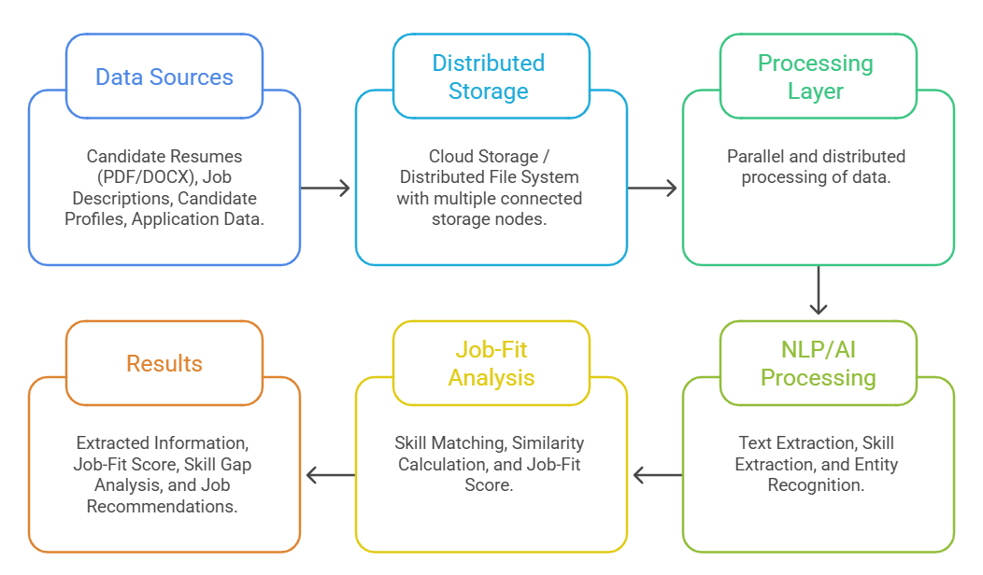

Question 5 (3 Marks)
List any three major security concerns in big data platforms and briefly explain each.

Explanation Notes

1 | Choose three concerns such as unauthorized access, data leakage, privacy violation, weak encryption, poor audit logs or insecure APIs.
2 | For each concern, explain the risk and not only the keyword.
3 | Add one control where possible: role-based access, encryption, anonymization, masking, logging or monitoring.
4 | Show awareness that big data combines many data sources, so security and governance become more complex.

Student Response
- Security is an important aspect of SkillHire because the application handles sensitive candidate and recruitment information. Some major security concerns include:
- Unauthorized Access: Unauthorized users may attempt to access candidate profiles, resumes, or recruiter information.
- Data Leakage: Personal information such as email addresses, phone numbers, qualifications, and employment history could be exposed if the system is not properly secured.
- Privacy Issues: Resumes contain personally identifiable information (PII), so the application must protect candidate information from unauthorized use.
- Authentication and Authorization: SkillHire should verify users and provide appropriate access permissions based on their roles.
- Secure Data Storage: Candidate resumes and profile information should be stored securely using appropriate access controls and encryption mechanisms.
- Data Transmission Security: Information transmitted between the Android application, backend services, databases, and cloud storage should be protected.
- Therefore, SkillHire should implement secure authentication, authorization, encryption, access control, and proper data-management practices to protect candidate and recruitment information.

Question 6 (3 Marks)
What are data appliances and integration tools? Explain their role in big data workflows.

Explanation Notes

1 | A data appliance is a specialized hardware/software platform optimized for storage, processing or analytics workloads.
2 | Integration tools move, transform or synchronize data between sources, storage systems and analytics layers.
3 | Mention ETL/ELT, API connectors, message queues, ingestion tools or workflow schedulers as examples.
4 | Explain the workflow: source data -> ingestion -> cleaning/transformation -> storage -> processing -> dashboard/decision.

Student Response

- Data appliances and integration tools help organizations collect, transfer, process, and manage data from different sources. In SkillHire, information can originate from multiple sources such as candidate resumes, user profiles, job descriptions, application records, and external APIs.
The data integration process can involve the following stages:
- Data Sources → Data Collection → Data Storage → Data Processing → AI/NLP Analysis → Job Matching → Results
- First, candidate resumes and job descriptions are collected through the Android application and other supported sources. The data is then stored in suitable cloud storage or databases. Processing tools are used to extract text and relevant information from documents.
- After preprocessing, AI/NLP techniques can identify important entities such as skills, qualifications, education, experience, and job requirements. The extracted information is then used by the job-matching component to calculate candidate-job compatibility.
- This integration enables SkillHire to combine information from different sources and provide a unified platform for AI-based resume screening and job-fit analysis.

- 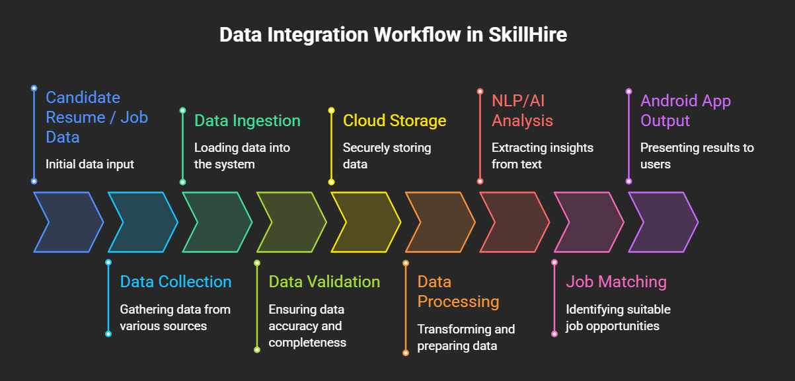

Question 7 (3 Marks)
Discuss two major challenges organizations face while implementing big data analytics.

Explanation Notes

1 | Pick two strong challenges such as data quality, skill gap, infrastructure cost, privacy compliance, integration difficulty or real-time scalability.
2 | Explain the cause and impact of each challenge.
3 | Suggest a practical mitigation for each challenge, such as governance, cloud scaling, training, access control or phased implementation.
4 | Try to connect the challenge to business impact, not only technical difficulty.

Student Response
Implementing Big Data solutions in SkillHire involves several challenges:
Data Quality: Resumes may contain incomplete, incorrect, duplicated, or inconsistent information. Poor-quality data can affect the accuracy of resume screening.
Scalability: As the number of candidates and job postings increases, the system must be able to handle the additional data without significant performance degradation.
Data Variety: Resumes can be available in different formats such as PDF and DOCX, while job descriptions may have different structures and writing styles.
Data Security: Candidate information must be protected from unauthorized access and data leakage.
Processing Complexity: Extracting meaningful information from unstructured resumes requires text processing and AI/NLP techniques.
Integration: Different databases, cloud services, APIs, and application components need to communicate effectively.
SkillHire addresses these challenges through appropriate cloud storage, scalable databases, preprocessing, AI/NLP-based extraction, secure authentication, and efficient data-processing mechanisms.

Question 8 (3 Marks)
Write short notes on any one domain application of big data analytics.

Explanation Notes

1 | Select one domain: healthcare, retail, agriculture, finance, education, smart city, transport or cybersecurity.
2 | Identify data sources in that domain.
3 | Explain how analytics converts raw data into decisions: prediction, recommendation, alert, optimization or risk detection.
4 | Mention one expected outcome such as reduced waiting time, fraud detection, crop advisory or improved user experience.

Student Response
SkillHire belongs to the domain of Intelligent Recruitment and Human Resource Analytics. Recruitment organizations need to process large numbers of resumes and job descriptions to identify suitable candidates efficiently.
In a traditional recruitment process, recruiters may manually read resumes and compare candidate qualifications with job requirements. This can be time-consuming, especially when the number of applications is high.
SkillHire uses AI-based techniques to automate this process. When a candidate uploads a resume, the system extracts relevant information such as technical skills, educational qualifications, work experience, certifications, and other important details. Similarly, job descriptions are analyzed to identify required skills and qualifications.
The extracted information is then compared to determine how well the candidate matches a particular job. The system can generate a job-fit score, identify matching skills and skill gaps, and recommend suitable job opportunities.
Thus, SkillHire demonstrates how Big Data and AI can improve recruitment by reducing manual screening effort, processing large volumes of candidate information, and supporting faster job-matching decisions.
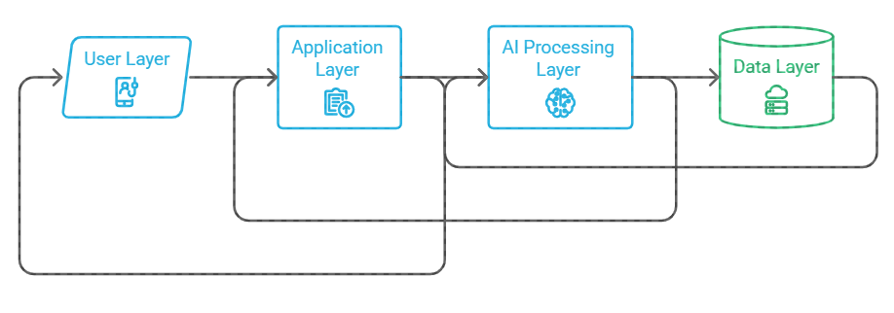

Question 9 (3 Marks)
xplEanxpaltaiionnthNeoitmepsortance of big data analytics in decision making.
How do business drivers influence the adoption of big data solutions?

Explanation Notes

1 | Business drivers are reasons that push an organization to adopt big data, such as cost reduction, personalization, speed, risk control or better decisions.
2 | Explain how each selected driver creates a technical requirement.
3 | Example: personalization requires behavior tracking and recommendation analytics; risk control requires fraud detection and monitoring.
4 | Conclude that big data adoption must be justified by measurable business value.

Student Response
The major business drivers for SkillHire include:
1. Operational Efficiency:
Manual resume screening requires considerable time and effort. SkillHire automates resume analysis and job matching, allowing recruiters and candidates to obtain relevant information more quickly.
2. Personalization:
Different candidates have different skills, qualifications, and experience. SkillHire can analyze individual candidate profiles and recommend jobs based on their skills and job-fit level.
3. Better Decision Making:
The application provides information such as matched skills, missing skills, and job-fit scores. This can help users make more informed decisions about job applications and candidate selection.
4. Scalability:
A cloud-based architecture can support an increasing number of users, resumes, and job postings without depending entirely on local storage and processing.
5. Reduced Screening Effort:
By automatically extracting and comparing relevant information, SkillHire can reduce the amount of repetitive manual work involved in initial resume screening.

Question 10 (3 Marks)

1 | Explain that analytics helps convert raw, high-volume data into useful patterns, predictions, alerts or recommendations.
2 | Differentiate descriptive, diagnostic, predictive and prescriptive decision support if space permits.
3 | Use one example: dashboard for hospital beds, forecast for demand, fraud alert for bank, traffic prediction for smart city.
4 | End with the idea that decisions become faster, evidence-based and scalable.

Student Response

Analytics plays an important role in SkillHire because it converts large amounts of recruitment data into meaningful information that can support decision making. Instead of simply storing resumes and job descriptions, analytics helps identify patterns, relationships, and useful insights from the collected data.
SkillHire can use four major types of analytics:
- Descriptive Analytics: Explains what has happened. For example, the system can analyze the number of applications received for different jobs.
- Diagnostic Analytics: Explains why something happened. For example, it can help identify why a candidate received a low job-fit score by examining missing skills or qualifications.
- Predictive Analytics: Estimates what may happen in the future. SkillHire can use candidate information and historical patterns to estimate job suitability or identify potentially suitable job opportunities.
- Prescriptive Analytics: Suggests what action should be taken. For example, the system can recommend suitable jobs to candidates or suggest skills that candidates should improve.
Therefore, analytics helps SkillHire move from simple data storage to intelligent resume screening, job-fit evaluation, skill-gap identification, and personalized job recommendations.

Submission Checklist

Checklist Item | Status | Remarks
Student details completed. | Done | Nothing
All 10 questions answered. | Done | Nothing
Examples are connected to cloud/capstone/domain context. | Done | Nothing

Security/privacy points are included wherever relevant. | Done | Nothing
Document exported as PDF if requested. | Done | Nothing
GitHub link shared through Google Classroom. | Done | Nothing

